## Sprout

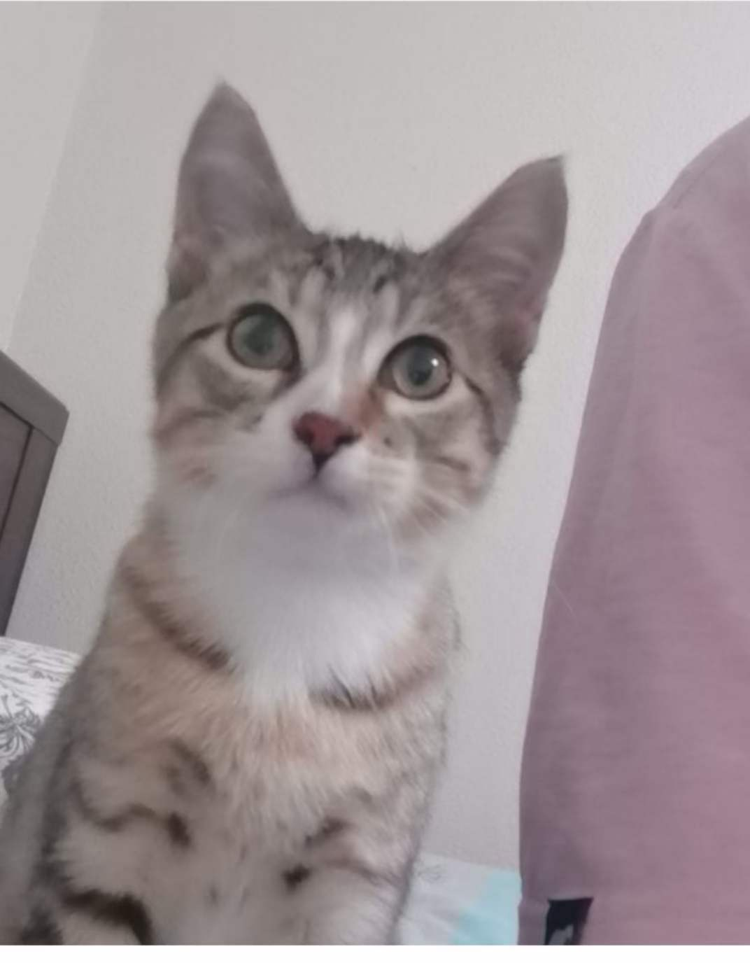

1. Sprout.jpg
2. This is Sprout as a kitten, in the new home, in their first photo together with Kai.
3. "Sprout, a shy and elusive kitten when he first arrived at four months old, gradually became an affectionate companion. He enjoyed sleeping on my bed, but his early morning wake-up calls at 6:30 AM were a daily routine.
4. During my challenging academic phase, Sprout became my constant companion during late-night drawing sessions, quietly curling up on my lap, providing comfort and banishing solitude.
5. **Photo Gallery**
6. Sprout_Baby.JPG
7. Photos of Sprout when he was born with his siblings
8. Sprout_toy.JPG
9. He likes to share his favorite toy with me, carrying it and offering it to me.
10. Sprout_withnaer.JPG
11. He enjoys playing together with his good friend Naer
12. Sprout_Kitten.JPG
13. The first photo together with kai
14. Sprout_withme.JPG
15. He likes to smell my fingers
16. Sprout_lying
17. He likes lying and sleeping in my chair and he doesn't like that I always work at night.
18. Sprout_kitten newhouse
19. We bought a new house for sprout.
20. **Likes**
21. Egg
22. Playing with Naer and my tennis string
23. Sleeping in the sunshine
24. Kai Liu and Mengkun